
Today's Date: 19-May-2015

PROPOSAL SPECIALLY PREPARED
FOR
INDOCHINA TRAVEL GROUP

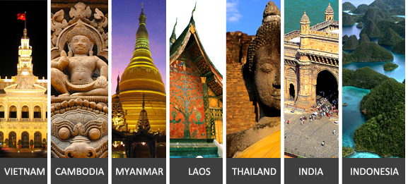

MYM Green Promo Package Asia Market
MYANMAR



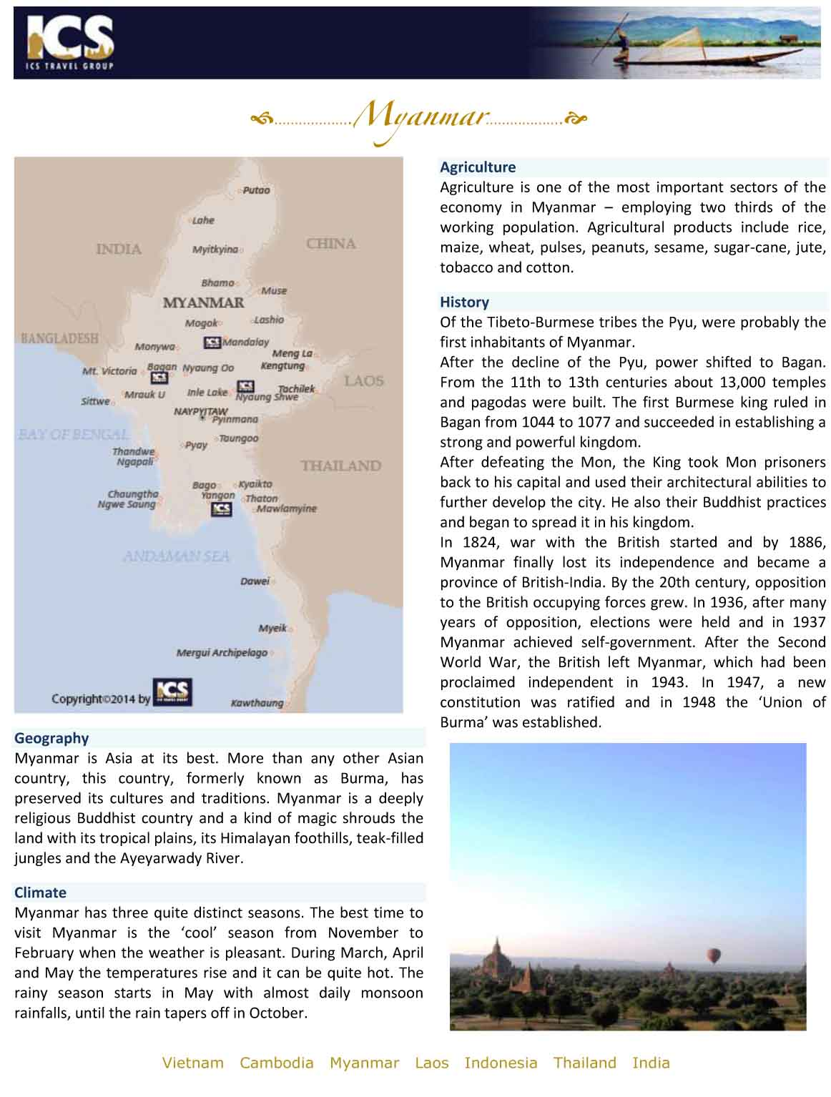

QUOTE REFERENCE # PRV1500239
MYM Green Promo Package Asia Market, 6 days

Day 1 | Yangon
Arrival in Yangon
Transfer (1.5 Hours)
Sightseeing in Yangon
Yangon lies in the fertile delta of southern Myanmar, on the wide Yangon River. The city is filled with tree-shaded boulevards, while shimmering stupas float above the treetops. The city became the capital only in 1885, when the British completed the conquest of Upper Myanmar and Mandalay's brief period as capital of the last Burmese kingdom ended.
Visit Sule Pagoda (30 Minutes)
Sule Pagoda is a 48 meter high golden dome used by the British as the nucleus of their grid development plan for the city when it was rebuilt in the 1880s. The pagoda's peculiarity is its octagonal-shaped stupa, which retains its shape as it tapers to the spire.
Visit Kandawgyi (Royal) Lake (30 Minutes)
Kandawgyi Lake, also known as the Royal Lake, is a natural body of water located in the city centre and a good place for strolling and picnics. The lake is attractive at sunset when the glittering Shwedagon pagoda is reflected in its calm waters.
Visit Chaukhtatgyi Pagoda (30 Minutes)
The reclining Buddha at Chaukhtatgyi Pagoda in Yangon which is almost as large as the enormous figure of Shwethalyaung Buddha in Bago. It's housed in a large metal-roofed shed on Shwegondaing Lan, only a short distance north-east beyond the Shwedagon Paya. Surprisingly, this huge figure is little known and hardly publicised at all- if the chance to go to Bago to see the Shwethalyaung was missed, then don't pass on this opportunity to witness this colossal image.
Visit Shwedagon Pagoda
The highlight of any visit to Yangon, the Shwedagon Pagoda dates back about 2500 years and was built to house eight sacred hairs of the Buddha. Its original shape has changed beyond all recognition over the centuries. Its bell-shaped superstructure, resting on a terraced base, is covered in about 60 tons of gold-leaf, which is continuously being replaced.
Overnight in Yangon
TIP OF THE DAY: Temples require visitors to take off shoes and socks, therefore, impress with a Longyi! Locals will really appreciate your taste of culture and might even ask to take a photo with you.

Day 2 | Yangon -Bagan (Breakfast)
Transfer (1.5 Hours)
Flight from Yangon to Bagan
Transfer (5 kms)
Sightseeing in Bagan (6 Hours)
Bagan is a spectacular plain stretching away from the Ayeyarwaddy River, dotted with thousands of 800-year old temple ruins. Although human habitation at Bagan dates back almost to the beginning of the Christian era, Bagan only entered its golden period with the conquest of Thaton in 1057 Ad. Visit many of the most important temples and sights including:

Shwezigon Paya: King Anawrahta started the construction of the paya to enshrine relics of the Buddha. The construction was finished by his successor, King Kyansittha between 1086 and 1090. Originally the Shwezigon Pagoda marked the northern end of the city of Bagan. The stupa's graceful bell shape became a prototype for virtually all later stupas throughout Myanmar.

Gubyaukhyi Temple at Wetkyi-Inn: This Temple was built in the early 13th Century and repaired in 1468. The great colourful painting depicting the previous lives of the Buddha and the distinguished architecture make it an interesting site for a visit. This temple should not be confused with the Gubyaukgyi Temple near Myinkaba village.

Ananda Pahto: one of the finest, largest, best preserved and most revered of the Bagan temples. Thought to have been built around 1105 by King Kyanzittha, this perfectly proportioned temple heralds the stylistic end of the Early Bagan period and the beginning of the Middle period.

Gubyaukgyi Temple at Myinkaba: Built in 1113 by Kyanzittha's son Rajakumar, this temple is famous for its well-preserved stuccos from the 12th century on the outside walls. The magnificent paintings date from the original construction of the temple and are considered to be the oldest original paintings in Bagan.

Shwesandaw Paya: In 1057 King Anawrahta built this Pagoda following his conquest of Thaton. This is the first monument in Bagan to feature stairways leading up from the square bottom terraces to the round base of the Stupa.

Also visit a lacquerware workshop. The villages around Bagan are known for producing the finest lacquerware in Myanmar. Stop by one of the workshops and learn about the painstaking process of laquerware making and decoration.
Watch sunset over Bagan (45 Minutes)
Enjoy a panoramic view of the sun setting over the plain of Bagan from one of the pagoda platforms.
Overnight in Bagan
TIP OF THE DAY: Sunset & Sunrise in Bagan are the most beautiful and memorable times of day. Be prepared with your camera at any pagoda you visit.

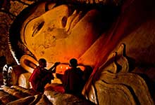 | 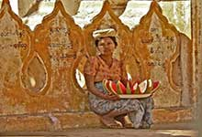 | 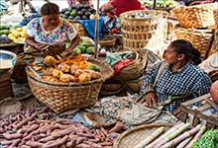

Day 3 | Bagan -Mandalay (Breakfast)
Transfer (5 kms)
Flight from Bagan to Mandalay
Transfer (1 Hour)
Excursion to Amarapura and Sagaing (6 Hours) (including U B, U P, U M)
In the morning, head to Amarapura former royal capital, and the Mahagandayon Monastery to observe monks and novices as they line up to receive their daily offering of alms and food from faithful Buddhists. Afterwards, visit the nineteenth century Pahtodawgyi Paya and the reconstructed Bagaya Kyaung, a close cousin to the monastery of the same name in Inwa (Ava). Pause to enjoy the atmosphere of U Bein Bridge, a picturesque teak bridge which extends over one kilometre across Taungthaman Lake, and the highlight of any visit to Amarapura.

Continue to Sagaing, another former royal capital and the spiritual centre of Myanmar. Hundreds of stupas, monasteries, temples and nunneries are to be found in Sagaing Hill, sometimes known as a living Bagan. Thousands of monks and nuns retreat here for meditation and contemplation. Stop at some of the most famous temples such as Sun U Ponya Shin Paya, U Min Thonsei paya and Kaung Hmu Daw Paya.
Sightseeing in Mandalay
Visit Mandalay Palace (Myanansankyaw Golden Palace) (1 Hour)
Visit Mahamuni Paya (30 Minutes)
Mahamuni Paya was originally built by King Bodawpaya in 1784 when a road paved with bricks was constructed from his palace to the paya's eastern gate. The centrepiece of the shrine is the highly venerated Mahamuni image that was transported to Myanmar from Mrauk U in Rakhaing in 1784.
Visit Shwe Inn Bin Monastery (30 Minutes)
Shwe Inn Bin Monastery: A Chinese merchant, U Set Shwin, married a local Burmese lady and with his newly acquired fortune built a monastery for his religious wife. It is built of teak, has Burmese carved doors and paintings depicting General Prendergast negotiating with court ministers prior to King Thibaw's exile.
Visit Mandalay Hill at sunset (1 Hour)
Visit Mandalay Hill and take an easy climb up sheltered steps to experience panoramic views over the palace, Mandalay and the paya-studded countryside. The famous hermit monk, U Khanti, is credited with inspiring the construction of many of the buildings on and around the hill in the years after the founding of the city.
Overnight in Mandalay
TIP OF THE DAY: Enjoy ice cream at the Nylon Ice Cream Bar in downtown Mandalay.

Day 4 | Mandalay -Heho -Inle Lake (Breakfast)
Transfer (1 Hour)
Flight from Mandalay to Heho
By vehicle from Heho to Inle Lake (1.5 Hours)
Transfer by boat (1 Hour)
Excursion by boat on Inle Lake
Enjoy a boat ride on Inle Lake and discover its calm serenity, still waters and colourful brush strokes of floating vegetation and slow moving fishing canoes. Rolling high hills hug the lake on all sides, as the lake's shore and islands host 17 villages on stilts, mostly inhabited by the Intha people. Enjoy the awe inspiring scenery and meditate on the one of a kind skill of the local fishermen who make use of their legs in a unique rowing technique to glide themselves gracefully around the lake. Visit the enchanting floating gardens, a teeming market and an Intha village around the lake. The day also includes a visit to the Phaung Daw Oo Pagoda, Inn Paw Khon Village (Lotus and silk weaving villages) and the Nga Phe Kyaung Monastery.
Overnight in Inle Lake
TIP OF THE DAY: Go for some delectable wine tasting at the Red Mountain Winery in Nyaung Shwe.

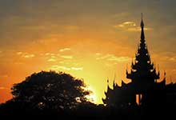 | 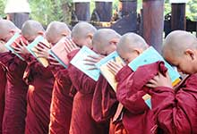 | 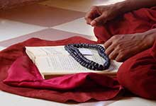

Day 5 | Inle Lake -Heho -Yangon (Breakfast)
Transfer by boat (1 Hour)
By vehicle from Inle Lake to Heho (1.5 Hours)
Flight from Heho to Yangon
Transfer (1.5 Hours)
Overnight in Yangon

Day 6 | Yangon (Breakfast)
Sightseeing in Yangon
Visit Bogyoke Aung San (Scott) Market (Close on Mondays and public holidays) (30 Minutes)
Explore the Bogyoke Aung San Market, also known as Scott Market, which contains over 2000 stalls and is the best place in Yangon to browse through the complete range of local handicrafts.
Afternoon at leisure
Transfer (1.5 Hours)
TIP OF THE DAY: Prepare some local pocket money before entering the famous Scott Market and get ready for bargaining!

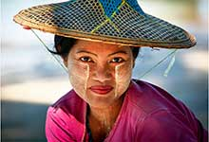 | 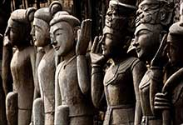 | 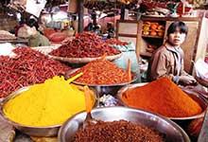

End of Services provided by ICS
**Note: Itinerary subject to change due to availability and schedules

Package price quoted NETT PER PERSON in US Dollar based on twin share
in US$ p.p | 2+ Pax | Sgl Suppl.
Var A. | 928 PER PERSON | 168 PER PERSON
Var B. | 1128 PER PERSON | 373 PER PERSON

**Note: Prices are current as of today but will be subject to any additional airfare, airport taxes and fuel increases that occur without our prior notice, and we reserve the right to adjust our quotes accordingly.
- Above rates are valid for 30 days from the date of quotation for travel between 01-Jun-15 to 30-Sep-15
Note: Significant overbookings are currently being experienced in Myanmar. Suppliers are increasing their rates without warning and certain hotels are not honouring contract rates and are applying significant rate increases. ICS Travel Group reserves the right to amend prices without notice where hotels and other suppliers increase their rates or additional surcharges are levied by airlines or government authorities.
- Surcharge for triple room (rate per room where extra bed is available): US$18 for Var. A. Single supplement will be charged where extra bed option is not available.
- Reduction for triple room (rate per room where extra bed is available): US$5 for Var. B. Single supplement will be charged where extra bed option is not available.
- Child reduction (sharing bed of parents): under 2 years FOC.
- Children under 12 years receive a 30% discount on adult rate (sharing bed of parents).
- Children requesting extra bed will receive the standard triple reduction as mentioned in our proposals.
- An additional surcharge may be applicable for bookings that fall within the Peak Season dates; Christmas, New Year and Water Festival. In these cases, ICS will automatically apply the additional charge and advise you immediately.

HOTELS
Location | Var. A | Var. B
Yangon | Hotel Grand United Ahlone Branch4*  Superior Room with Panoramic/Pagoda View  http://www.hotelgrandunited.com | Sule Shangri-La Hotel (F.Traders Hotel)5*  Superior  http://www.shangri-la.com
Bagan | The Hotel Umbra2*  Deluxe | Bagan Thiripyitsaya Sanctuary Resort4*  Deluxe River View  http://www.thiripyitsaya-resort.com
Mandalay | Hotel Amazing Mandalay3*  Deluxe  http://www.amazing-hotel.com | Sedona Hotel Mandalay4*  Superior  http://www.sedonahotels.com.sg,http://www.sedonasmyanmar.com
Inle Lake | Pristine Lotus Spa Resort Inle5*  Floating Duplex (no extra bed for TPL available)  http://www.pristinelotus.com | Aureum Inle Resort & Spa5*  1st Row Villa  http://www.aureumpalacehotel.com

Accommodation in hotels is subject to availability. If the listed hotel is fully booked, alternate accommodation will be offered. All hotels are rated by ICS at its discretion.
Note: There is no standard method of rating hotels, transport services, guides etc across the world. Many countries have difering official and unofficial ways of assessing these services and some do not rate services at all. ICS uses its discretion to rate services. Agents should check with ICS at time of booking to clarify which level of service is being booked and notify this to clients.

INCLUDED SERVICES:
- English-speaking guide.
- Accommodation in hotels as mentioned above or equivalent.
- Meals according to itinerary / Breakfast box in lieu of ABF when early morning flight
- Flight ticket(s) as mentioned in the itinerary.
Flight from Yangon to Bagan
Flight from Bagan to Mandalay
Flight from Mandalay to Heho
Flight from Heho to Yangon
- Porter fees at the airport where guide service is booked.
- Current fuel surcharges are included, however, these are subject to change prior to tour start date.
- Boat ticket(s) according to the itinerary.
- Ground transportation in private A/C vehicle
- 1 complimentary bottle of drinking water and 1 cold towel per person per half day tour/ 2 bottles of water and 2 cold towels per person per full day tour.
- Sightseeing incl. admission fees according to itinerary.
- International and domestic airport taxes in Myanmar are automatically included in ticket.

EXCLUDED SERVICES:
- Visa fees, drinks, personal expenses | Myanmar

Remark for Myanmar bookings: as ICS works with many suppliers throughout Myanmar, it is possible some may require higher non-refundable deposits prior to confirmation of booking, or between the time of booking and the dates of travel. Additionally, some suppliers may require separate cancellation fees in excess of the non-refundable deposit when rooms or services are cancelled. ICS will make every effort to notify you as early as possible of these requirement deposits and special cancellation terms.

Please note that general terms and conditions apply as stated in our Terms and Conditions; unless indicated otherwise. | Terms and Conditions; | unless indicated otherwise.

**Flight ticket penalties may apply if changes or cancellations are made outside of 21 days prior to arrival date. You will be advised of ticket issuance deadlines if any are outside of our cancellation policy time frame.

To guarantee the quote a written booking request, or purchase order must be received by ICS within the validity period. Series contracts and catalogue contracts are exempt.
ICS reserves the right to re-price, alter or revise this quotation if:
- Your booking request is received after the 7-day validity period
- There is an increase of airport tax, fuel surcharge or ticket fare.

Indochina Services (S) Pte. Ltd.
RS Tower, 35th Floor
121/096-097 Rachadapisek Road,
Dindaeng, Bangkok 10400
Telephone : (+66) 2 2487485 Fax : (+66) 2 2488509 - 10
ICS Travel Group 2015

